CDN’s Research Program Manager launches new
Cultural Centre in rural Timor-Leste

In a sideline to her day job with the Cultural Development Network, Research Program Manager Kim Dunphy also does what non-researchers might consider ‘real work’. Over the last six years, she has been working with cultural anthropologist Holly Schauble to establish a community Cultural Centre in rural Timor-Leste. The two made a lightning visit to Timor recently, in between events in CDN’s forum series on cultural planning, for the official inauguration of the Centre.

Holly established the community organisation Many Hands International in 2008 to promote cultural assets-based community development in Timor, one of the world’s newest and poorest nations. Her idea was that through the support and development of a strong community asset, the local culture, the isolated rural community of Lospalos might benefit culturally, socially and economically. These ideas were strongly aligned with Kim’s interests in community cultural development, and complementary to her work at CDN promoting cultural vibrancy of communities in Australia, and the pair began collaborating.

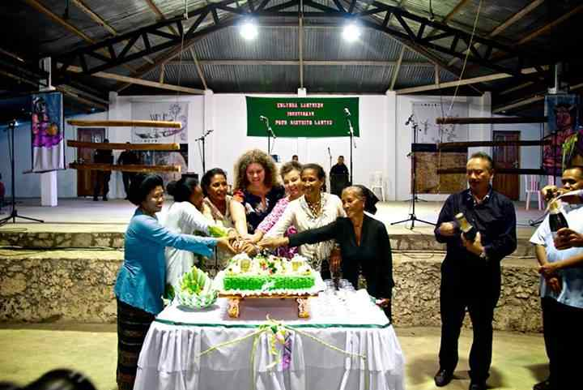
Image: Holly Schauble and Kim Dunphy celebrate with members of the Lospalos Centre Inauguration Committee. © Austraining International.

Through MHI, Holly and Kim have managed to attract a huge amount of support for the town of Lospalos, a six hour drive from the capital city Dili. The University of Melbourne got the ball rolling by providing funding for a posse of skilled building volunteers to visit Timor. This team developed detailed plans for the re-development of the old Portuguese market-place into a community cultural centre. Led by architect Richie Blight, the team’s work was sufficiently compelling for the Timorese government to fund the capital costs of the building, and a partnership for the project was established between MHI and the State Secretariat for Arts and Culture.
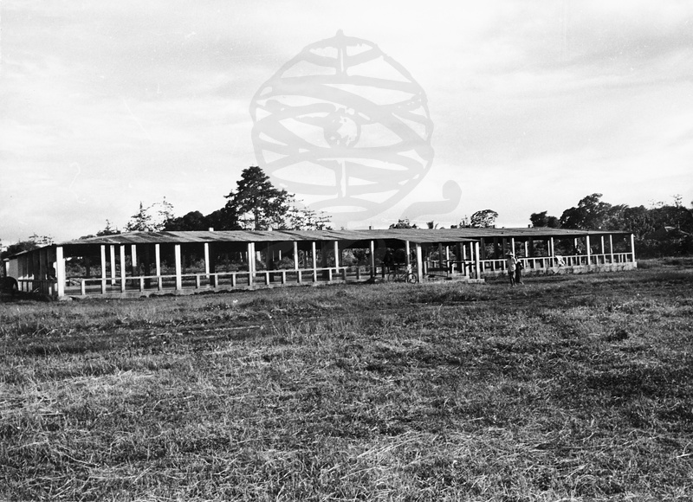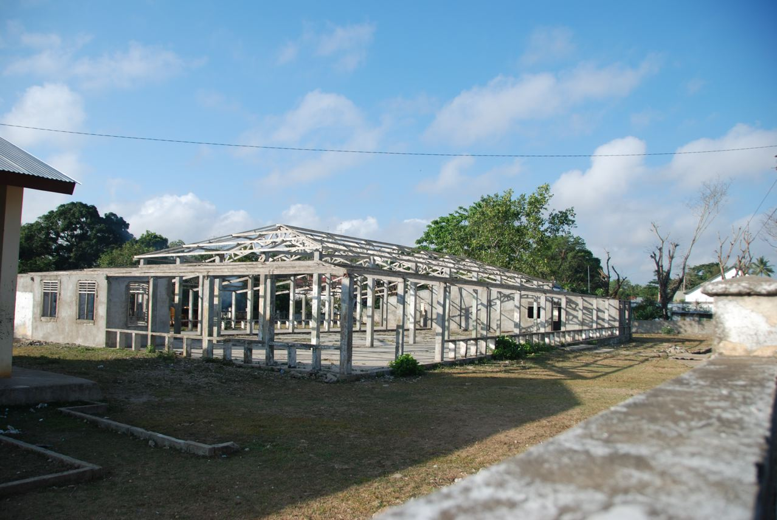

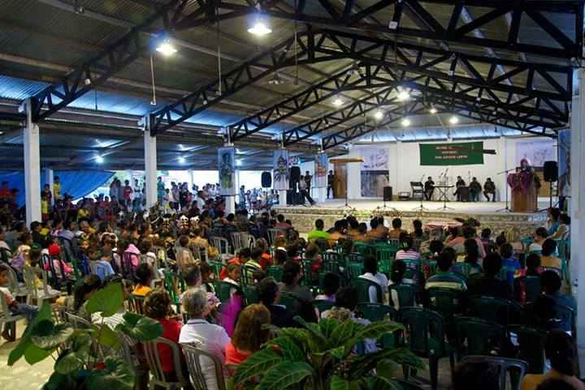
Images: Lospalos Old Market 1973, 2009 and 2014 © Austraining International.

This month the Lospalos Cultural Centre project reached a major milestone, with the completion of the renovation into a beautiful open-air performing arts space with change rooms, storerooms, kiosk and ticket-box. The development of a derelict office building next door into a dance studio, small gallery, offices, and workshop space was also completed.

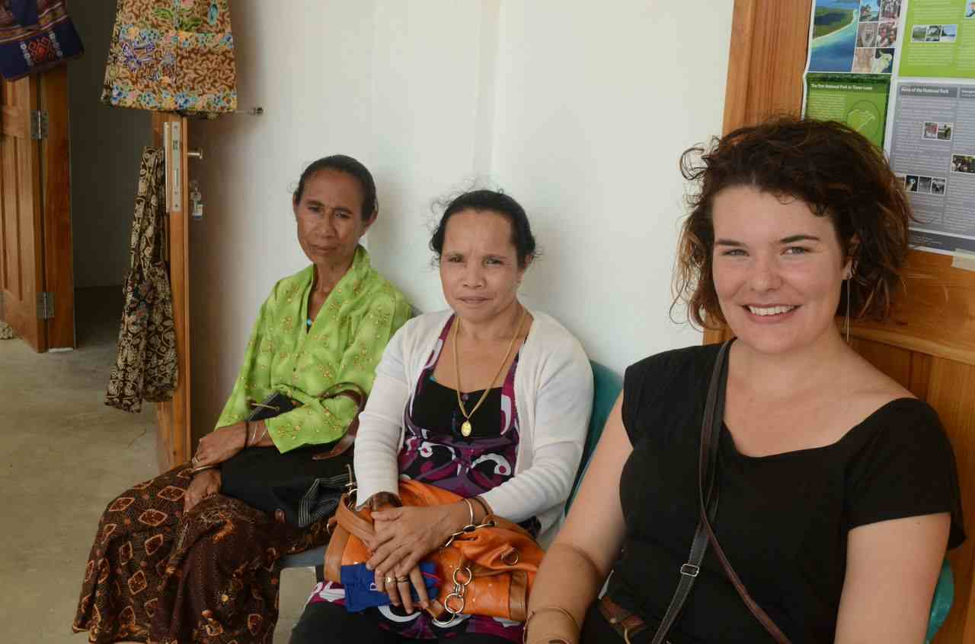
Image: the new building hosts a handicraft fair for the Inauguration celebrations.
© Austraining International.

The official inauguration of the Centre on May 1 was attended by many senior government officials, including the Minister of Tourism, the Secretary of State for Arts and Culture, the Vice Minister of Secondary Education, the General Director of Culture, and Directors of all Culture departments.

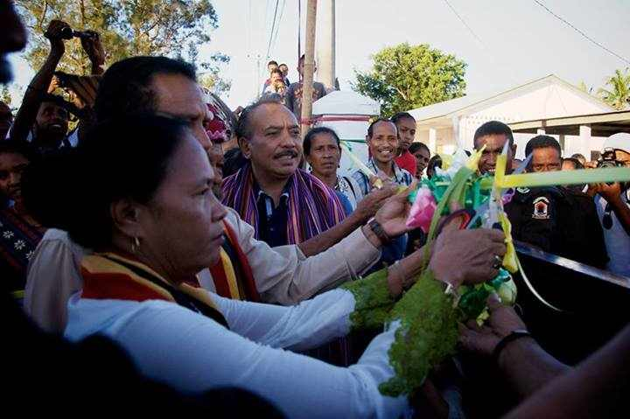Image: State Secretary for Arts and Culture, Sra Isabel Ximenes
© Austraining International.

Community members from across Lospalos and the wider Lautem district contributed, with many local groups performing traditional and contemporary music and dance.

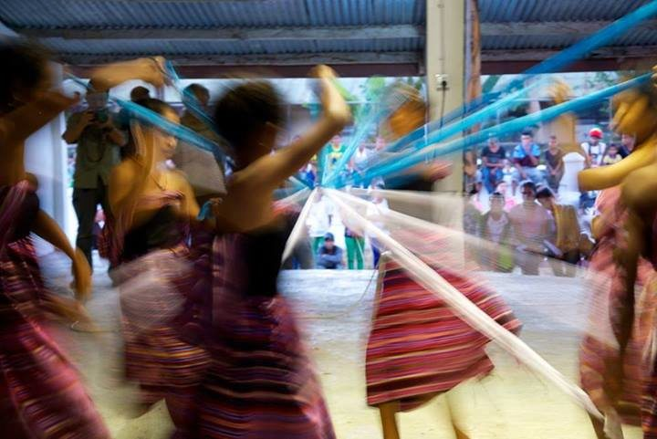
Image: Local dance group Sanggar Haburas © Austraining International.

The official program concluded with a lively Stomp Choir, possibly the first ever performed in eastern Timor-Leste, created by local artist Etson da Costa Caminha working with young people from the community.

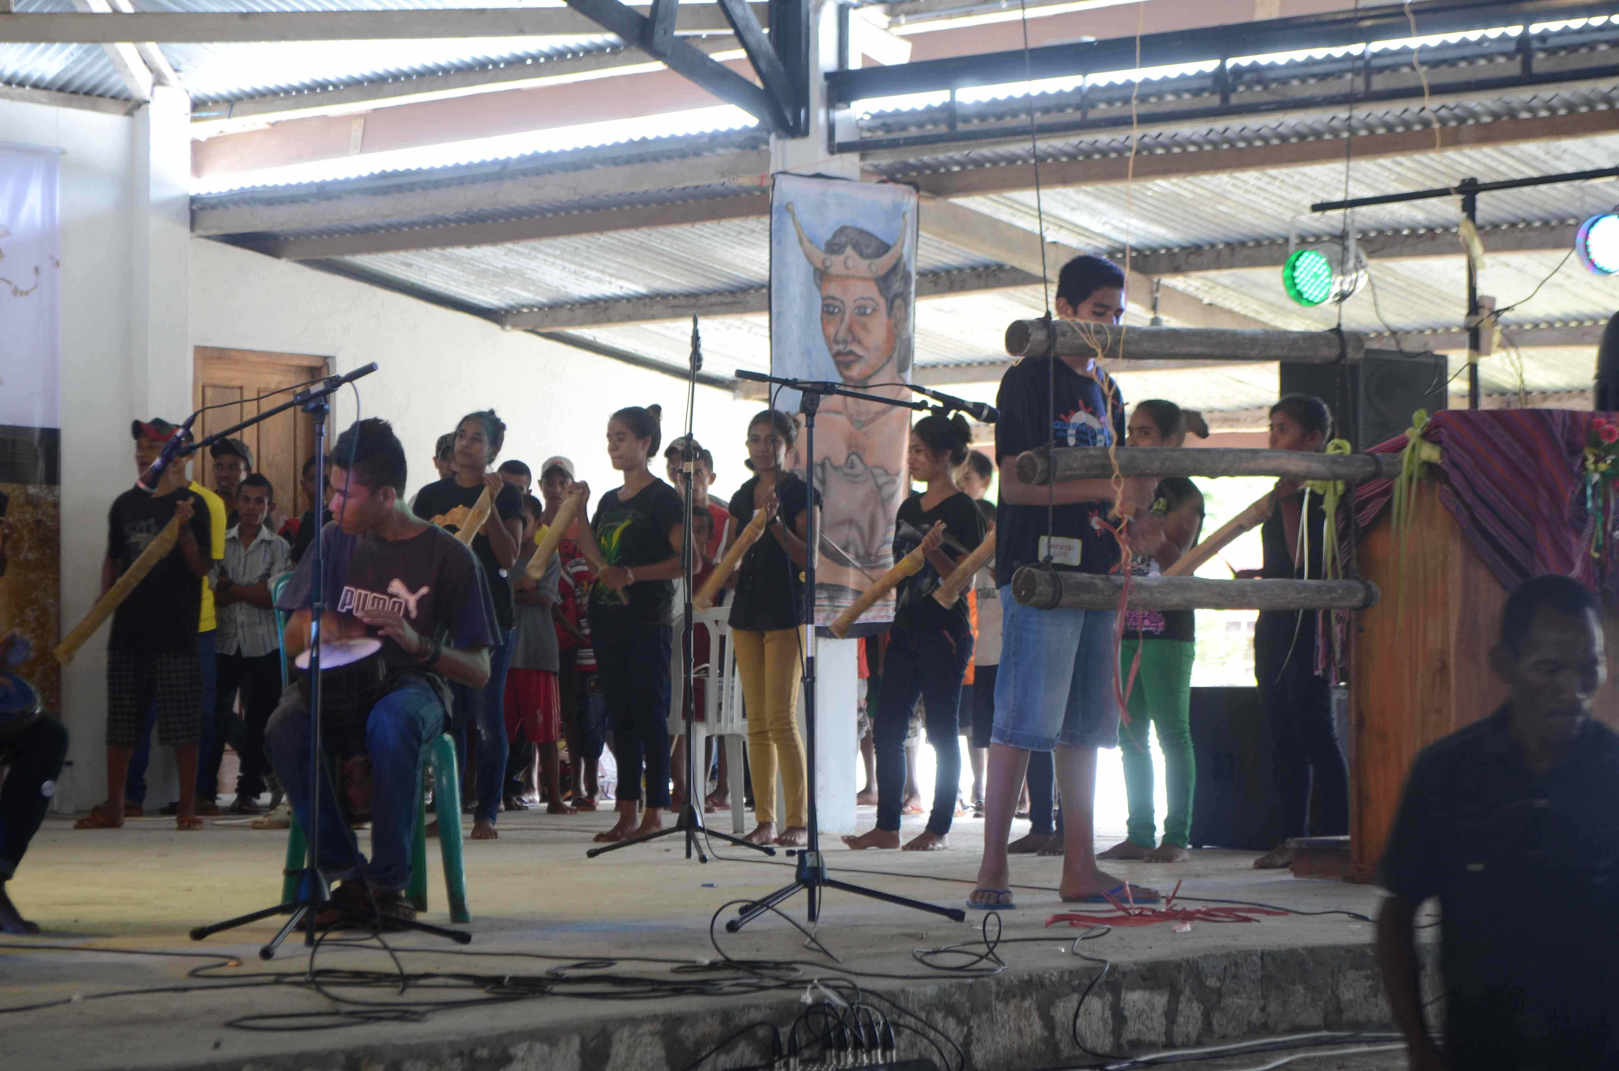
Image: Stomp Choir

The government of Timor-Leste, through the State Secretariat for Arts and Culture, are now planning to fund ongoing operations and a team of staff for the Centre. Community members in Lospalos contribute through membership of committees for events including last year’s celebratory Festival of Culture. Additional funds and a significant amount of volunteer labour come from Australian people and organisations. Currently two Australia volunteers, Lucia Pichler and Amy Stevenson, live and work in Lospalos, sharing skills with local staff in the activation of the Centre. Their positions are supported by the Australian government through the AVID program.

Many Hands International has hosted a range of other cultural activities since its inception, including two Asialink residencies, of Gillian Howell and Catherine Simmonds, who led successful music and theatre projects in Lospalos. Two book publishing projects in partnership with Kids’ Own Publishing of Melbourne, Alola Foundation, volunteer Tash Trenear and funded by AusAID resulted in the publication and distribution of thousands of beautiful picture books. These are amongst the first ever children’s books in local language Fataluku.
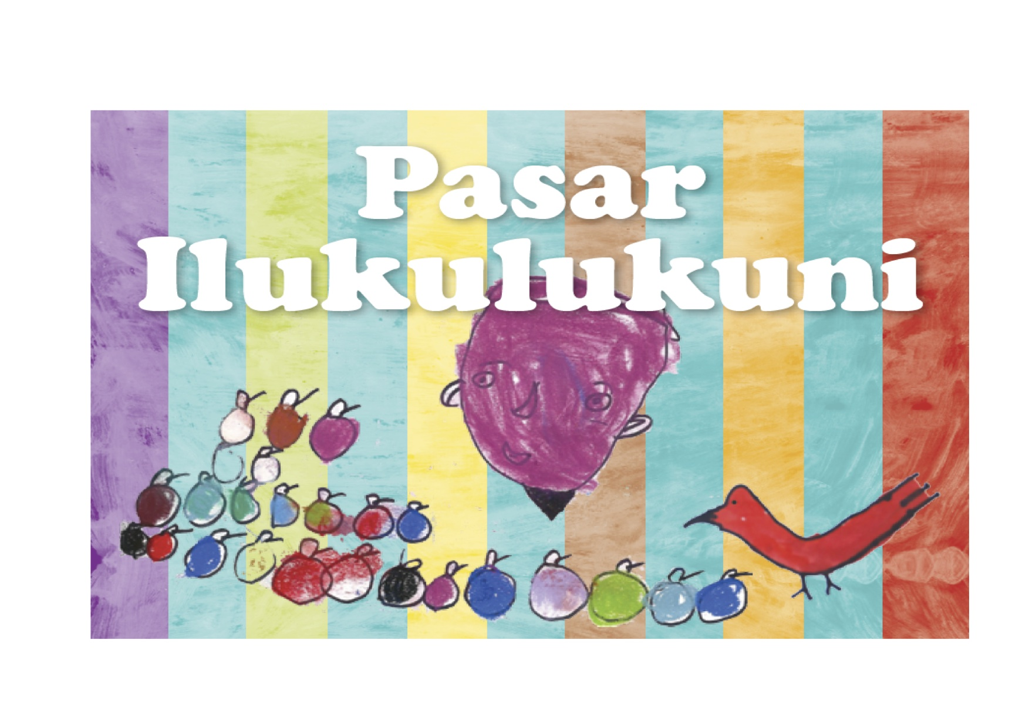
Image: Cover of book created by Tash Trenear, community members with Kids’ Own Publishing

The Lospalos Centre is the first of series of community cultural centres that the Timorese government plan to establish across the whole country, making possible a much greater engagement of Timorese in creative cultural activities. Donations and volunteers with skills in arts management and community cultural development are always welcome at the Centre.

Contact: kim.dunphy@manyhands.org.au
Read more about Many Hands International, and view photos of the Cultural Centre Inauguration

